INTERNATIONAL CIVIL AVIATION ORGANIZATION

Dangerous Goods Technical Course

BULLETIN
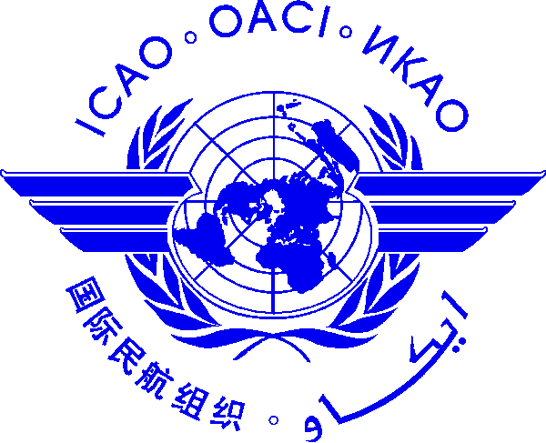

1. Schedule of Course

1.1 The Dangerous Goods Technical Course will be held at the Meeting Room I, Kotaite Wing of ICAO Asia and Pacific Office Bangkok, Thailand as per the following schedule:

- Initial Training on Dangerous Goods Technical Instructions, 21-25 January 2013
- Specialized Training- Infectious Substances, 28 January 2013
- Specialized Training- Radioactive Materials, 29 January 2013
- Recurrent Training on Dangerous Goods Technical Instructions, 30 January to 1 February 2013

1.2 The course will commence at 08:30 hrs. daily.

2. Registration of participants

2.1 Participants are requested to register at the Registration Desk between 08:00 and 08:30 hours on the opening day of the Course. Participants are also requested to wear the identification badge all the time inside the ICAO premises.

3. Officers and Secretariat concerned with the Course

3.1 Mr. Amal Hewawasam, Regional Officer, Flight Safety, ICAO Asia and Pacific Office, will act as Coordinator of the Course.

3.2 The daily conference services are the responsibility of Ms. Sarangtip Sundarachampaka, Administrative Officer, and Ms. Aemiga Sirivichitvorakarn, Secretary to the Flight Safety Section.

3.3 Any inquiries related to the Meeting should be addressed to:

Fax: +66 (2) 537-8199
E-mail: apac@icao.int Cc: khun.nong@coscap-icao.org

4. Location of the ICAO Regional Office

4.1 The ICAO Bangkok Regional Office is located at 252/1 Vibhavadi-Rangsit Road, Chatuchak, next to the Petroleum Authority of Thailand (PTT) Headquarters and opposite the Sofitel Central Plaza Bangkok. It is about 35 km. away from the Suvarnabhumi International Airport and about 12 km. from the Sukhumvit Road, where most of the recommended hotels are located. Location of the Regional Office and the route map of the Bangkok Mass Transit System (BTS, also known as the Sky train) and MRTA Sub-way system (the Underground Metro) are published in the APAC website http://www.Bangkok.icao.int under the heading “Information for Visitors”.

4.2 The nearest BTS (Sky train) station to the Office is Mor Chit and the nearest MRTA station to the Office is Phahon Yothin. Detailed routing instructions are provided on the web site.

5. Passport, visa and customs

5.1 All foreign nationals entering Thailand must possess valid passports or other valid documents for travel. Participants from certain countries are not required to obtain visas for a temporary visit not exceeding 15 days. It should, however, be noted that the temporary visas issued upon arrival at the Airport cannot be extended beyond the period of 15 days except under extraordinary circumstances. It is, therefore, suggested that all participants consider obtaining official visas from the Royal Thai Embassy or Consulate prior to their arrival in Thailand.

5.2 International certificates of vaccination against yellow fever are required if arriving within 6 days after leaving or transiting an infected area.

5.3 Following items can be brought in duty free:

a) Personal effects such as clothing etc.
b) 200 cigarettes or 250 grams of cigar or tobacco.
c) 1 litre alcoholic beverages. d) Perfume for personal use.

5.4 There are no restrictions on import of foreign currency. However, if the amount exceeds US$10,000 it must be declared on entry. Foreign currencies may be taken out of the country up to the amount imported and declared. (Current exchange rate US$1 = Baht 30.00 approx).

6. Hotel reservations, arrival and departure

6.1 Information giving the details of the address, fax number, tariff, etc. of hotels is provided at ICAO APAC website http://www.bangkok.icao.int (under “Information for visitors”). Participants should contact the hotel directly for reservation.

6.2 Participants are requested to make their own arrangements for transportation from the Airport to the city.

6.2.1 Thai Airways International and Airport Taxi Services operate private limousine services from the Airport to downtown Bangkok, at about Baht 1000-1200 per vehicle. Public taxi meter service is also available at the Airport. In addition to the fare indicated in the taximeter, 50 Baht extra surcharge is required to be paid for hiring a taxi from Airport to city plus express way toll charges if any. The Bangkok Mass Transit Authority operates Airport Bus service to the city centre.

6.2.2 When departing, the hotel can arrange for transportation to the airport. Public taxis, which are less expensive than hotel taxis, are also available. Most taxis have a fare meter.

6.2.3 Participants are requested to ensure that their return bookings are confirmed as required.

6.2.4 Participants are requested to make their own arrangements for transportation from their hotels to the venue of the Meeting.

7. Other Useful Information

7.1 Time in Thailand is 7 hours ahead of Co-ordinated Universal Time (UTC+7).

7.2 International credit cards such as American Express, Diners Club, Visa, Master Card, etc. are normally accepted at major hotels and department stores.

7.3 All commercial banks exchange major foreign currencies and are open from 0830 to 1530 hours from Monday through Friday and some keep the foreign exchange counter open until 2000 hours during weekdays. Foreign exchange counters operated by various commercial banks are located at several places in the city and are also open during Saturdays and Sundays and on public holidays from 1000 to 2000 hours. To change travellers’ cheques you are required to show your passport.

7.4 Information about Bangkok climate could be found on the ICAO APAC website. More weather information including 5-day forecasts can be obtained from the web site of the Thai Meteorological Department: www.tmd.go.th.

7.5 Tropical or lightweight and washable cotton clothing’s/dresses will suffice.

7.6 Most hotels add a 10% service charge to the room rate in addition to the government tax of 7%. Baggage boys at hotel expect a tip of at least Baht 20. At restaurants, a tip of about 10% is expected unless a service charge has been added to the bill.

7.7 Although the tap water in Bangkok is chemically treated, it is, however, recommended that participants drink only bottled water and beverages.

— END —

